**Indoor Positioning & Tracking System**

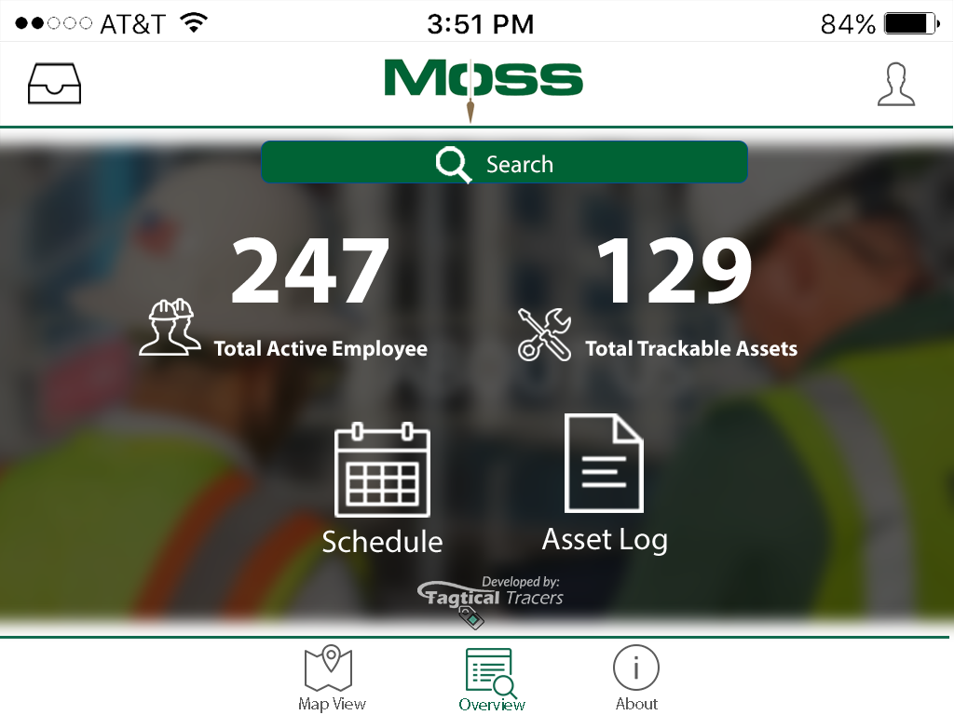

## Team Members:

* Robert Standifer (EE)

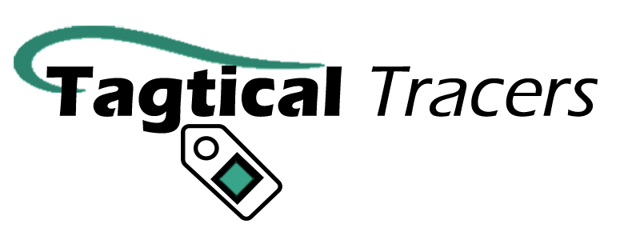

* Andres Gordo (EE)
* Kirsten Marie Palma (ME)
* Xiaoxi Zheng (DAS)
* Ricky Tran (CE)
* Phone Myint (EE)

Client Company: Moss and Associates

## Coach: Professor Eisenstadt

­­

*This is an active ongoing project during Fall 2016 semester

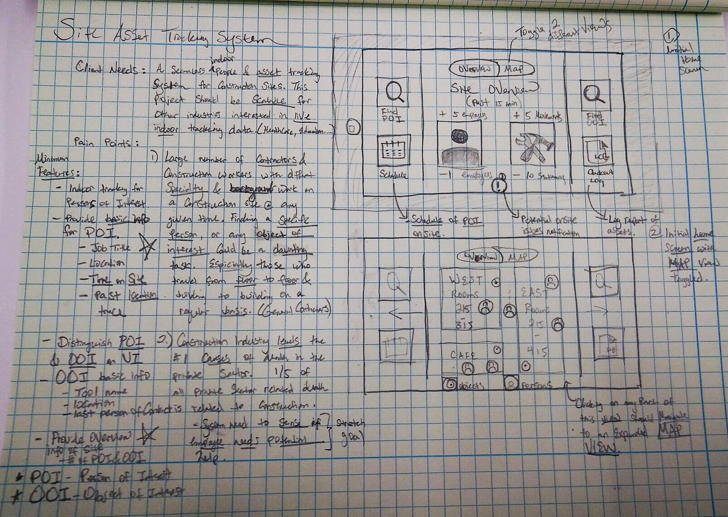

Summary:

We are creating a seamless IoTsystem for asset and people tracking. For this prototype, we are focusing on configuring the system to fit the construction industry. This indoor asset tracking system is planned to be scaled for other industries interested in live indoor tracking.

We’ve identified several pain points for our client to develop this system:

Pain point 1: Large numbers of contractors & construction workers of different specialty and background work on a construction site at any give time. Finding a specific person with a particular knowledge on an active construction is a challenge.

Pain point 2: Construction industry leads the #1 cause of death in the private work sector. With indoor live data on active construction sites, this system will provide the extra layer of protection in cases of emergency.

Pain point 3: Different indoor assets gets displaced all the time by different active workers, this system will provide a layer of asset tracking at the end of the day.

From the initial UI sketches, you will find us focusing on the two pain features. Finding what we define as Person of Interest (POI), and Object of interest (OOI). In the center of the interface, we define to give an overview of the site actively from our tracking devices.